|  |  |
| --- | --- |
| Course Name | ITD 2313 – Script Programming |
| Instructor | Mr. Schnell |
| Student Name | Bridgette Johnson |
| Due date | 22 January 2023 |
| Grade | Put grade earned here |
| Grading Comments | Put instructor comments here |

Textbook Exercises for Week 2

Page 49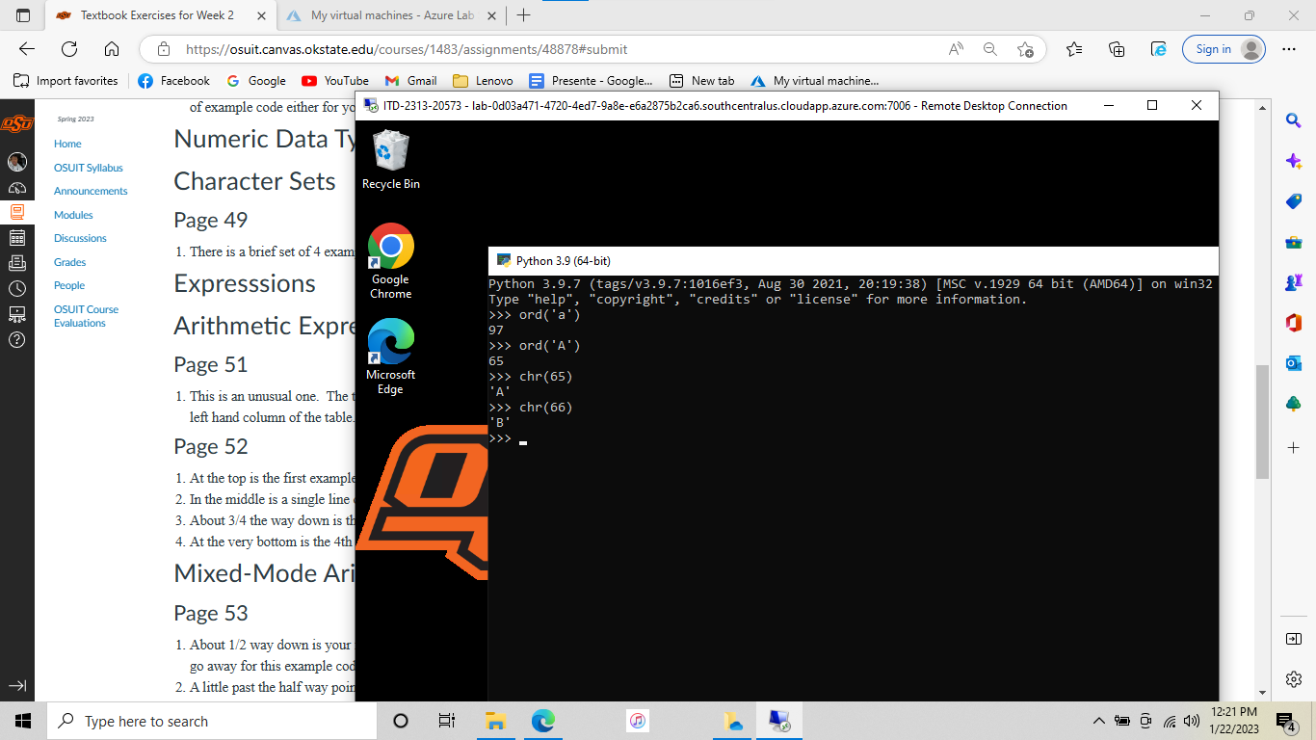

Page 45 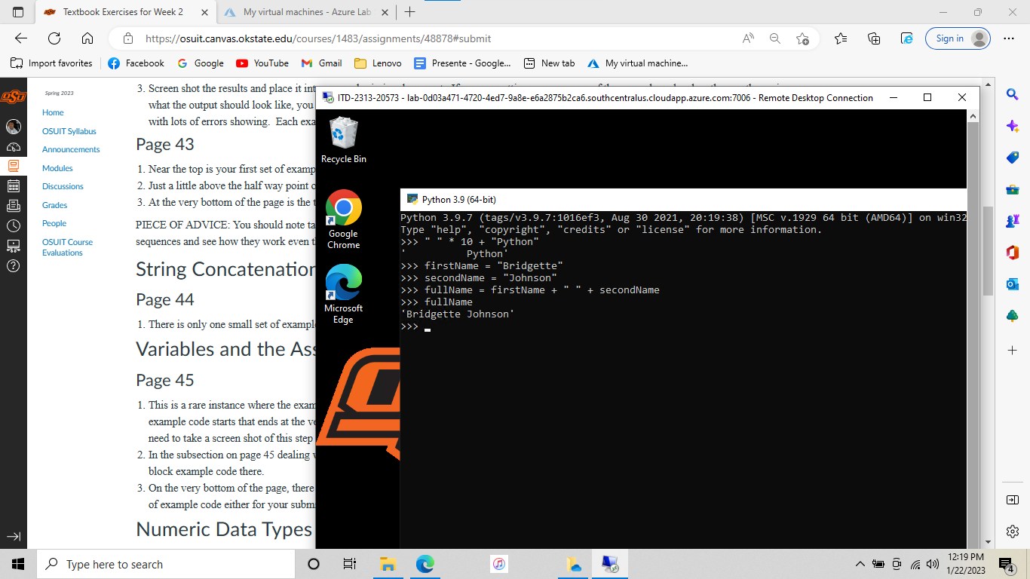

Page 43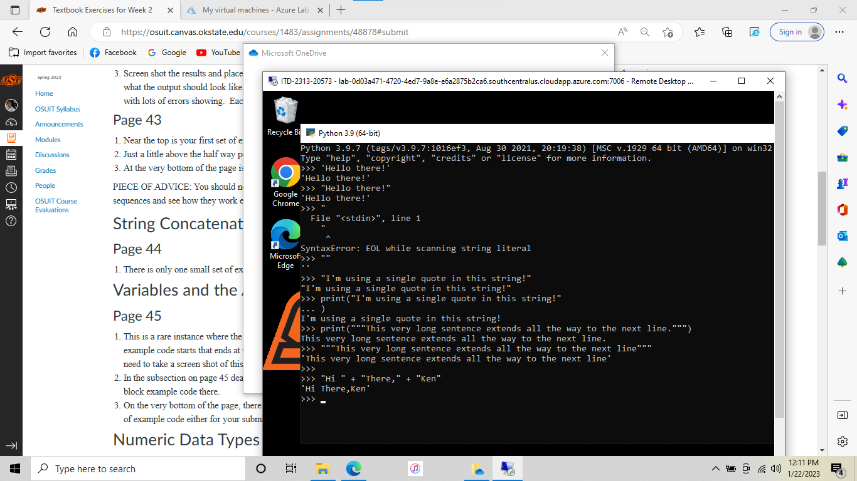

Page 42

